**DAV HZL SR. SEC. SCHOOL, DARIBA**

**TENTATIVE CO-CURRICULAR ACTIVITIES 2024-25**

|  |  |  |
| --- | --- | --- |
| **Date** | **Class** | **Activity (Events)** |
| 06/04/2024 | III TO V | Cinematic Odyssey: Arya Samaj Chronicles |
| VI TO VIII | Narrative Alchemy: Crafting English Tales |
| IX TO XII | Lens Enchantment: Interclass Cinematic Journey |
| 20/04/2024 | III TO V | Soliloquy Symphony: Mastering English Monologues |
| VI TO VIII | Dramatic Flourish: Theatrical Skits in English |
| IX TO XII | Electoral Insights: Interclass PowerPoint Showdown |
| 04/05/2024 | III TO V | Artistry Unleashed: Collage Creation Extravaganza |
| VI TO VIII | Sculpting Stories: From Clay to Chronicle |
| IX TO XI | Pixel Perfection: Design Delights with Photoshop |
| 05/07/2024 | III TO VIII | Green Horizon: Plantation Expedition |
| 06/07/2024 | III TO V | Calligraphy |
| VI TO X | Echoes of Ecology: English Environmental Orations |
| 11/07/2024 | III TO XII | Leadership Unveiled: Investiture Spectacular |
| 20/07/2024 | III TO V | Lexical Showdown: Spellbinding Spell Bee |
| VI TO VII | Verbal Voyage: Vocabulary Ventures |
| IX TO XI | Enlightening Discourse: TED Talk Showdown |
| 03/08/2024 | III TO V | Culinary Chronicles: Fireside Cooking & Artistry |
| VI TO IX | Taste Temptations: Culinary Competition |
| 17/08/2024 | III TO VIII | Cultural Kaleidoscope: Rangoli, Rakhi& Arya Samaj Quizzes |
| 31/08/2024 | III TO V | Social Science Showdown: Quiz Quest |
| VII TO X | Parliamentary Prowess: Youth Debate Showdown |
| 06/09/2024 | III TO V | Hindi Heritage: Crafting Original Stories & Poems |
| VI TO VII | Hindi Heritage: Crafting Original Poems |
| VIII TO X | Declamatory Divinity: Hindi Oratory Odyssey |
| 05/10/2024 | III TO V | Blogosphere Brilliance: Crafting Digital Chronicles |
| VI TO VII | Wall Wonders: Mural Masterpieces |
| VIII | Wonders on earthen plates |
| 19/10/2024 | III TO V | Moral Mosaic: Hindi Skits on Values |
| VI TO IX | Theatrical Tribute: Great Personality Dramatizations |
| 08/11/2024 | III TO V | Melodic Medley: Songster Showdown |
| VI TO IX | Devotional Delights: Bhajan Bliss |
| 23/11/2024` | III TO V | Innovation Illuminated: Inventors' Showcase |
| VI TO VII | Journey of a Dreamer;Biography |
| VIII TO IX Sci. | Scientific Sorcery: Enchanting Science Magic |
| 07/12/2024 | III TO V | Literary Legacy: Bookmark Bonanza |
| VI TO VIII | Informative Imprints: Brochure Brilliance |
| 21/12/2024 | III TO IX | Math Marvels: Exploring Fun & Practical Mathematics |
| 18/01/2025 | III TO VII | Patriotic Penmanship: Slogan Sketching & Doodling |
| 31/01/2025 | III TO V | Resourceful Innovation: Waste Material Wonders & Presentations |

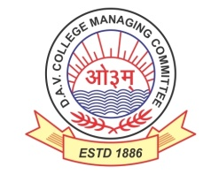

DAV HZL Sr. Sec. School dariba

rajsamand (raj.)

DAV HZL Sr. Sec. School dariba, rajsamand(raj.)

Split-up Syllabus

Class- III

Split-up Syllabus & Activities

for the session

2024-25

Class-IV

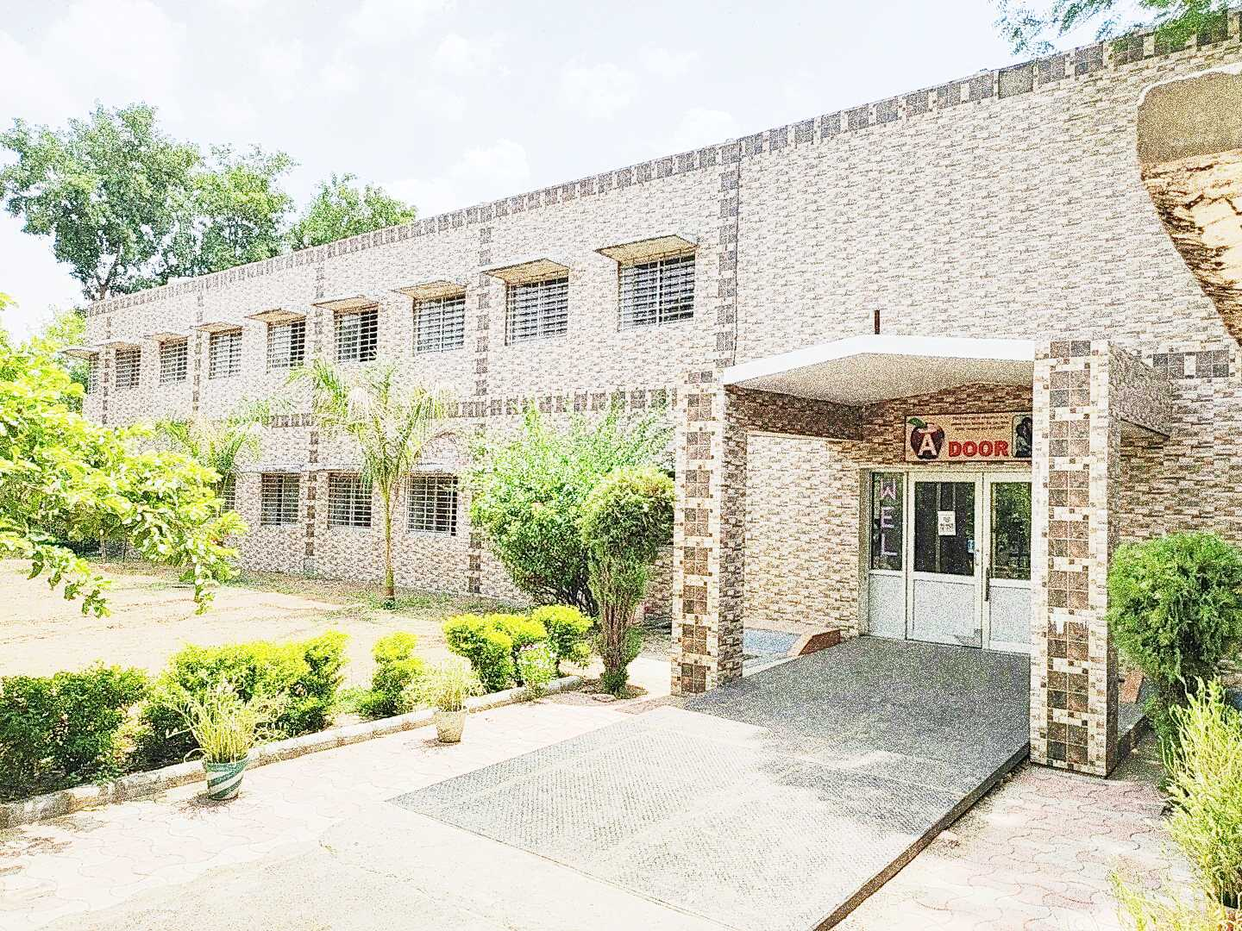

Address : Rajpura-Dariba, Distt. – Rajsamand (Raj.) 313211

Contact : (02952)265130 Email : davhzl_dariba@yahoo.com Website : www.davhzldariba.in

|  |  |  |
| --- | --- | --- |
| **Subject** | **PT- I** | **PT- II** |
| English | Reader Book - Unit - 1 Sports  L. – A True Friends  English Practice Book Ch. – 1 Naming words | Reader Book L. – 2 Mix up at Birth  English Practice Book Ch. – 2 Genders |
| Hindi | Hkk"kk ek/kqjh ikB & 1 , 2  Hkk"kk vH;kl ikB & 1 , 2 | Hkk"kk ek/kqjh ikB & 3 , 4  Hkk"kk vH;kl ikB & 3 , 4 |
| Maths | Ch. – 1 ,2 | Ch. –3 , 4 |
| EVS/ Science | Chapter – 1 ,2 | Chapter – 3, 4 |
| S.St. | Chapter - 1 ,2 | Chapter – 3 & 4 |
| Computer Sci. | Chapter – 1 | Chapter – 2 |
| Moral Edu. | ikB & 1] 2 | ikB & 3 , 4 |
| G. K. | Unit – 1 | Unit – 2 |

|  |  |
| --- | --- |
| **Subject** | **Mid Term** |
| English | My English Reader – Unit – 1 Sports ,Unit – 2 Travel  English Practice Book – Lesson – 1 to 5 |
| Hindi | Hkk"kk ek/kqjh % ikB & 1 ls 9 rd  Hkk"kk vH;kl % ikB & 1 ls 9 rd  vifBr x|ka'k] dkWih esa djok;k x;k dk;Z |
| Maths | Chapter – 1, 2, 3, 4, 5, 6, 7 |
| EVS/ Science | Chapter – 1 to 5 |
| S. St. | Chapter – 1 to 7 |
| Computer Sc. | Chapter – 1 to 4 |
| Moral Edu. | ikB & 1 ls 7 |
| G. K. | Unit – I to III |
| Drawing | Page No. 2 to 20 |

|  |  |
| --- | --- |
| **Subject** | **PT- III** |
| English | Reader – Ch. – The Rich Lady and the Artist  Practice Book – Ch. 6 Determiners |
| Hindi | Hkk"kk ek/kqjh ikB & 10 ,11  Hkk"kk vH;kl ikB & 10,11 |
| Maths | Chapter – 8, 9 |
| EVS/ Science | Chapter – 6, 7 |
| S.St. | Chapter – 8, 9 |
| Computer Sc. | Chapter – 5,6 |
| Moral Edu. | ikB & 8] 9 |
| G. K. | Unit – 4 |

|  |  |
| --- | --- |
| **Subject** | **Final Term** |
| English | Reader – Unit – 3 Wit and Humour , Unit – 4 Fantasy  Practice Book – Lesson – 6 to 10 |
| Hindi | Hkk"kk ek/kqjh ikB & 10 ls 18  Hkk"kk vH;kl ikB & 10 ls 18  vifBr x|ka'k] dkWih esa djok;k x;k dk;Z |
| Maths | Chapter – 3,4, 8, 9, 10, 11, 12, 13, 14 |
| EVS/ Science | Chapter – 6, 7, 8, 9, 10 |
| S. St. | Chapter – 8 to Chapter – 13 |
| Computer Sc. | Chapter – 5 to 8 |
| Moral Edu. | ikB & 8 ls 13 आर्य समाज के नियम 1 व 4 |
| G. K. | Unit – 4 to Unit - 6 |
| Drawing | Page No. – 21 to 40 |

|  |  |
| --- | --- |
| **Exam** | **TENTATIVE DATES OF EXAM** |
| **PT – I** | First Week of May 2024 |
| **PT- II** | First Week of August 2024 |
| **MID – TERM** | Third Week of September 2024 |
| **PT – III** | Last week of November 2024 |
| **FINAL TERM** | Last Week of Feb.2025 |